* Virtual network with name Virnet1

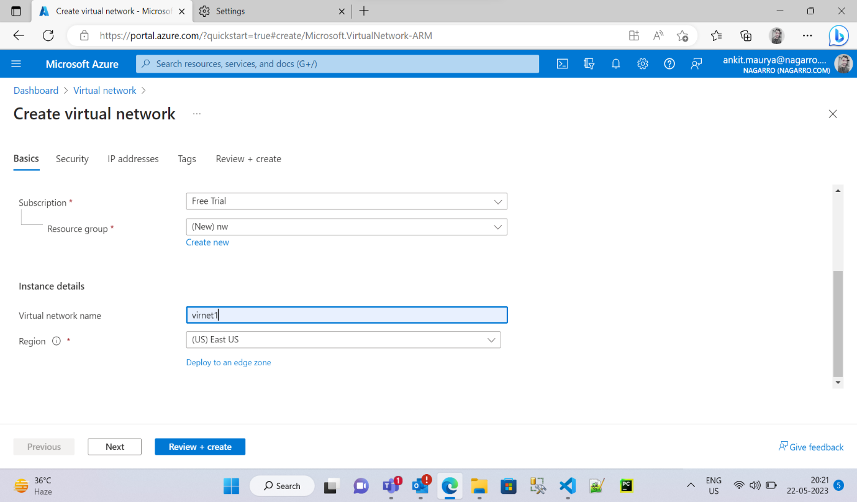

* Adding Subnet1

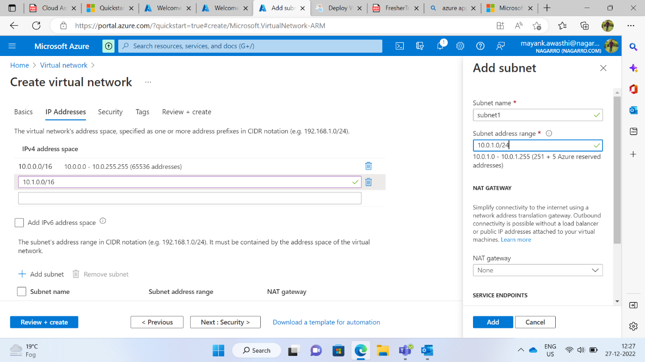

* Adding Subnet2

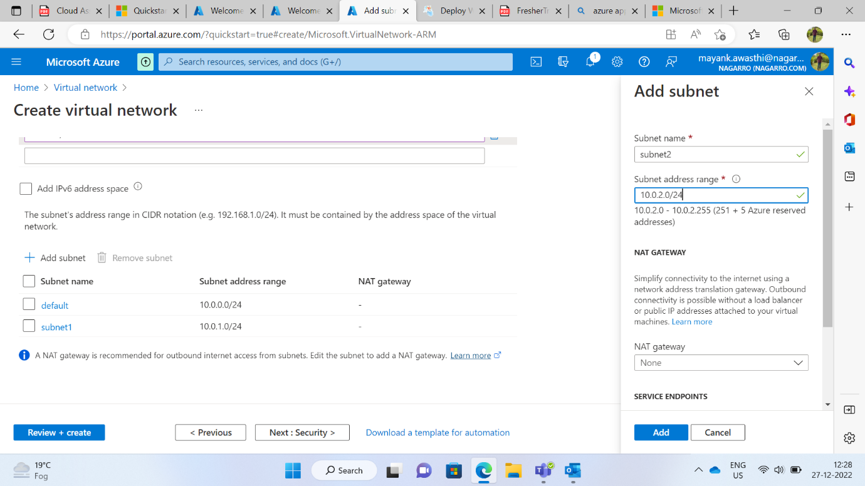

* Virtual Network deployment

* Virtual Machine VM

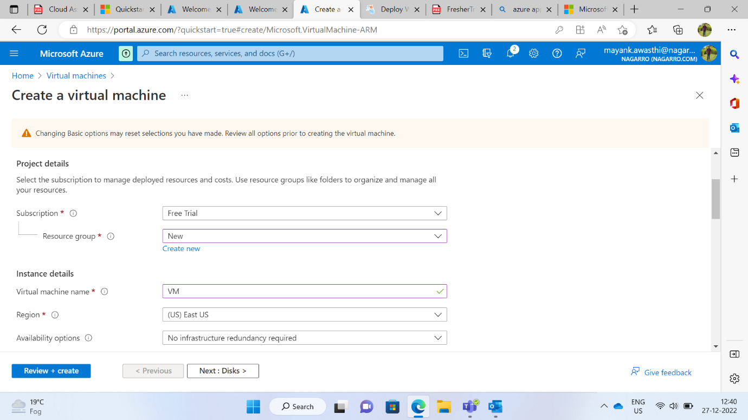

* Azure Web App Service

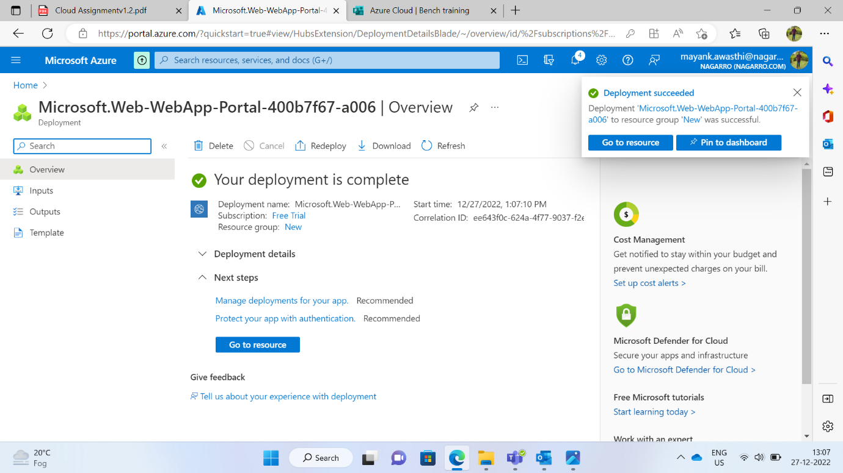

* Azure Kubernetes service Cluster

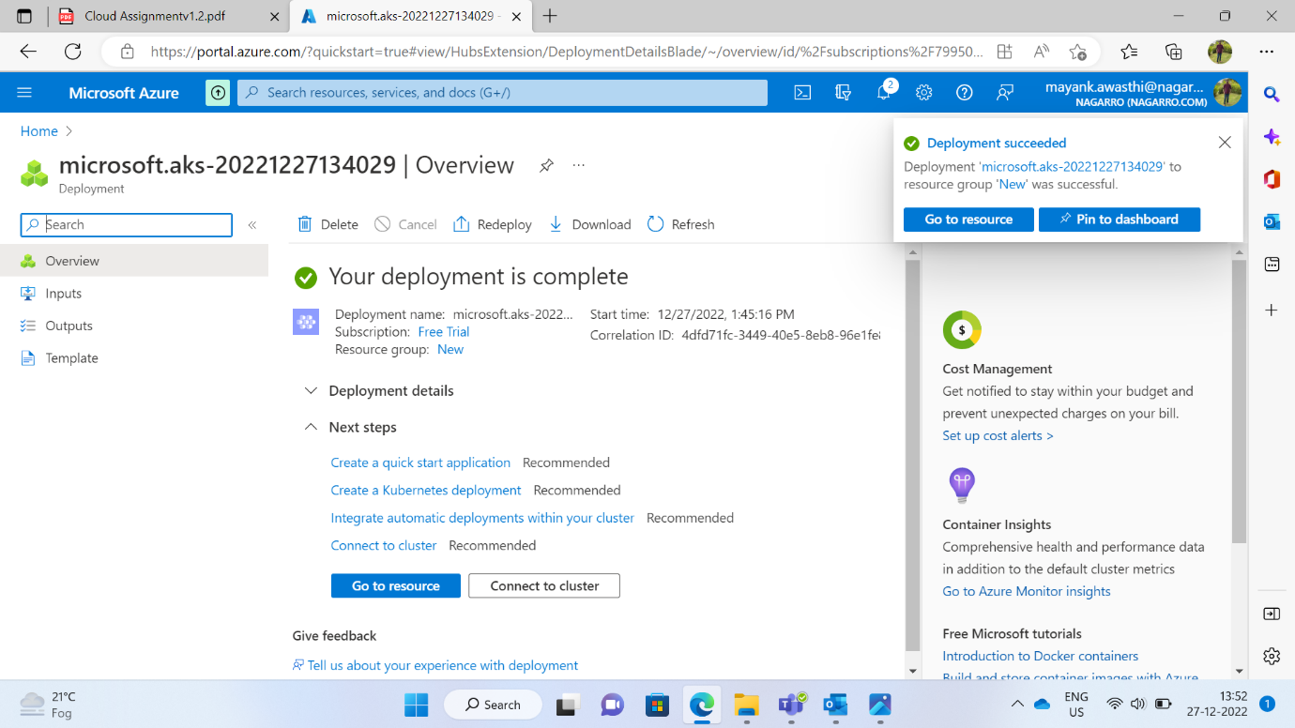

* Blob Storage

* Function App

* Container in blob storage

